ZH,
REPORT OF JOINT INVESTIGATION VISIT BY NOSDRA, SPDC, RIVERS STATE MINISTRY OF ENVIRONMENT AND BONNY COMMUNITY REPRESENTATIVES AT BONNY OIL AND GAS TERMINAL EMULSION TANK (T1201B) @ BONNY IN BONNY L.G.A OF RIVERS STATE.
INTRODUCTION
Acting on your directives on the SPDC request, a Joint Investigation Visit (JIV) was conducted at the Bonny Oil and Gas Terminal Emulsion Tank (T1201B) in Bonny L.G.A of Rivers State on the 13th of April, 2017 at about 11:10Hrs. This was a follow-up to the first visit of 7th April, 2017; where the Agency was not invited. The investigation was completed successfully on the same day. This report provides details.
INCIDENT PARTICULARS: 2017_ 1832519
FACILITY AFFECTED: BONNY OIL AND GAS TERMINAL EMULSION TANK (T1201B) @ BONNY IN RIVERS STATE.
DATE OF SPILL: 30/03/2017
DATE OF INSPECTION: 13/04/2017
CAUSE OF SPILL: OPERATIONAL ERROR (Process Upset which lead to Overfilling and Overflow of Emulsion Tank see Fig.1a & b)
QUANTITY OF CRUDE OIL SPILLED: 41.60bbls (Approximately 42bbls)
SPILL POINT COORDINATES: N 04^{O} 25’ 43.22’’
E 007^{O} 10’ 08.29”
NATURE OF IMPACT: Medium
INVESTIGATION TEAM:
- Koms Abam NOSDRA
- Okuese Ohis SPDC
- Chinedum Oji SPDC
- Ibitoru Dasu RIVERS STATE MINISTRY OF ENVIRONMENT
- Sidney Sunju Allison BONNY COMMUNITY (BECC)
OBSERVATIONS:
- On arrival to the Spill Area by the Joint Investigation Team (JIT), the Terminal Operators explained that, there was power outage in Bonny Oil and Gas Terminal which resulted in Process Upset and Overfilling of Emulsion Tank (TANK 1201B – BRAVO) from the “STATIC HEAD” of the Drainage Tank. This led to an Overflow and Spillage of a mixture of Oil and Water (Emulsion) within the Farm Tank. (See Fig. 1a & b)
- They further explained that, the Emulsion Tank was Isolated and the Bund Wall Sluice Gate was closed and Power restored to the Facility, but one of the Automated Control Valves did not short-down during the process, so it took a little time for the Terminal Staff to move over and short it down manually.
- The Spill Occurred within SPDC Right of Way – ROW (Tank Farm) due to the Process Upset and Overfilling and contained within the Recovery Pit and the Bund Wall Area. It was an Operational Spill. (See Fig. 2a & b). The grasses within the Spill Area were affected.
- The Impact covered a Total Area of 0.13HA with a Volume of approximately 42 Barrels of Emulsion infiltrating the Laterite (Soil Type), with Free Phase Oil observed/enclosed within the Bund Wall. (See Fig. 3a & b).

IMPACTED AREA COORDINATES:
- N 04^{O} 25’ 43.67’’ 2. N 04^{O} 25’ 42.81’’ 3. N 04^{O} 25’ 42.34’’
E 007^{O} 10’ 09.19” E 007^{O} 10’ 07.86” E 007^{O} 10’ 08.21”
4. N 04^{O} 25’ 43.37’’ 5. N 04^{O} 25’ 44.65’’ 6. N 04^{O} 25’ 44.01’’
E 007^{O} 10’ 06.76” E 007^{O} 10’ 07.86” E 007^{O} 10’ 08.23’’
7. N 04^{O} 25’ 43.54’’ 8. N 04^{O} 25’ 44.70’’ 9. N 04^{O} 25’ 43.38’’
E 007^{O} 10’ 08.72” E 007^{O} 10’ 07.85” E 007^{O} 10’ 06.71”
10. N 04^{O} 25’ 43.68’’ 11. N 04^{O} 25’ 42.30’’
E 007^{O} 10’ 09.22” E 007^{O} 10’ 08.21”

RECOMMENDATIONS
- The area should be cleaned up.
CONCLUSION
The JIV was successful. This report is subject to your steer and further directives.

Koms Abam
SES

_____________________________
16th April, 2017

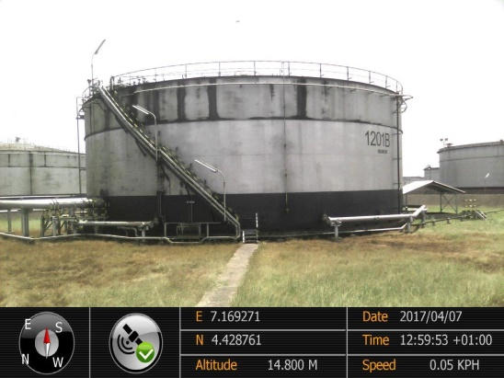 ` 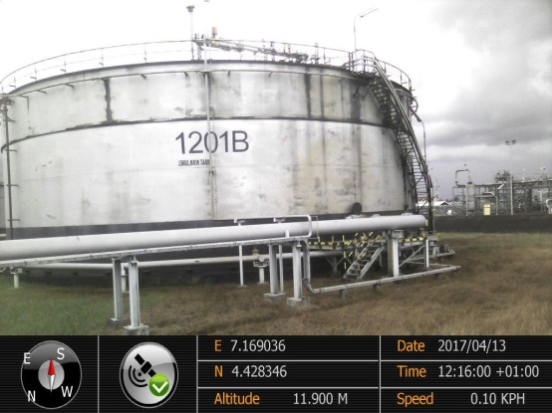
Fig. 1a Tank 1201B-Bravo Fig.1b Showing Leak Point
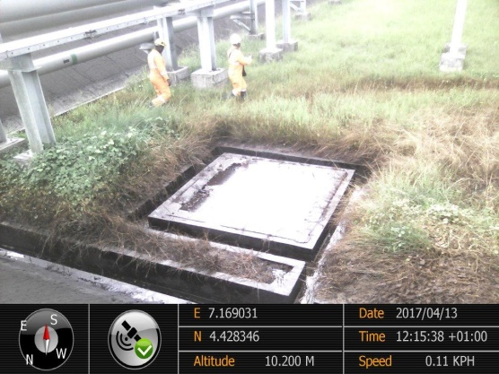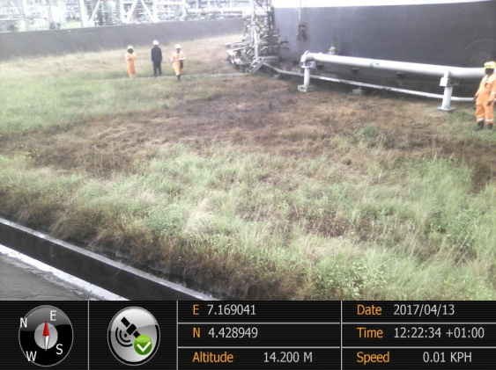
Fig. 2a Emulsion contained within Pit Fig. 2b Impacted Grasses within Bund Wall
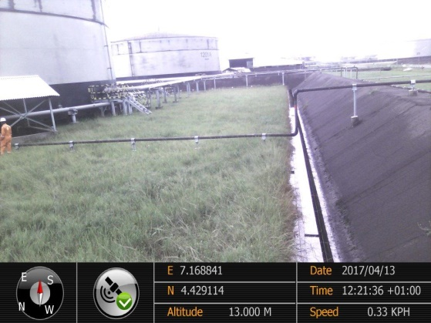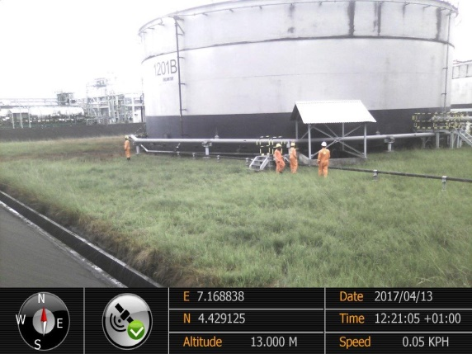
Fig. 3a Free Phase Oil within Bund Wall Fig. 3b Impact within ROW

